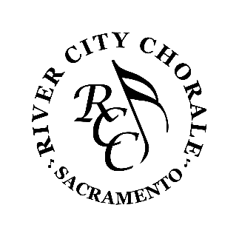
RIVER CITY CHORALE
Mail Order Ticket Form
Holiday Concert - Friday, December 01, 2023, 7:30 PM or Saturday, December 02, 2023, 4:00 PM
Ticket Type | Quantity | Price | Total
Adult |  | $20.00 | $
Child - 12 & under |  | $5.00 | $
Student – with student ID |  | $10.00 | $
 |  | Holiday Total | $
POPS Concert - Friday - February 23, 2023, 7:30 PM or Saturday - February 24, 2024, 4:00 PM
Ticket Type | Quantity | Price | Total
Adult |  | $20.00 | $
Child - 12 & under |  | $5.00 | $
Student - with student ID |  | $10.00 | $
 |  | POPS Total | $
Spring Concert - Friday - May 10, 2024. 7:30 PM or Saturday - May 11, 2024, 4:00pm
Ticket Type | Quantity | Price | Total
Adult |  | $20.00 | $
Child - 12 & under |  | $5.00 | $
Student - with student ID |  | $10.00 | $
 |  | Spring Total | $
Season Tickets (All 3 Concerts)
Ticket Type | Quantity | Price | Total
Adult |  | $50.00 | $
Child - 12 & under |  | $10.00 | $
Student - with student ID |  | $20.00 | $
 |  | Season Tickets Total | $

Thank you for your tax-deductible gift | $
Grand Total | $
Please make checks payable to RCC
Name:
Address:
City: | Zip:
Phone:
Email:

Send to: River City Chorale  6620 Silver Springs Ct.  Citrus Heights, CA 95621 | For more ticket Information:  (916) 622-1109

